Troop 116 PLC Meeting Agenda 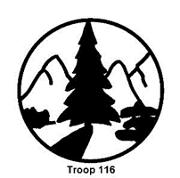
Date:
Activity | Run by
Opening and Call to Order | Senior Patrol Leader
Roll Call | Troop Scribe

Roll | Present
SPL
ASPL
ASPL
Patrol Leaders:
Avocado
Dead Moose
Nuclear Llama
Red Phoenix
New Scout A
New Scout 1
Quartermaster
Troop Guide
Scribe
Historian
Chaplain’s Aide
Leave No Trace
OA Rep
Scoutmaster
Other

Activity | Run by | Notes
Reading of the Log (Minutes) | Troop Scribe
Patrol Reports | Patrol Leaders
Old Business | Senior Patrol Leader
Troop 116 PLC Meeting Agenda Date:

Activity | Run by | Notes
Main Event  Planning | SPL | Event:
Troop Meeting  Planning | SPL | Troop Meeting Dates:
New Business | SPL | Upcoming Troop Events:  Next PLC date:
Wrap-Up/  Actions Assigned | Scribe/  SPL | Action POC Date
Scoutmaster’s Minute | Scoutmaster

