Upcycle shirt craft ideas –

Note: recommend the following for 12 & up, but you know your girls; their abilities and interests. Any variation can include fringe braiding, beading, clamping together, tying bows or knots with strips, or lacing (with or without grommet or eyelet strips, and can involve any part of the shirt). Be creative!

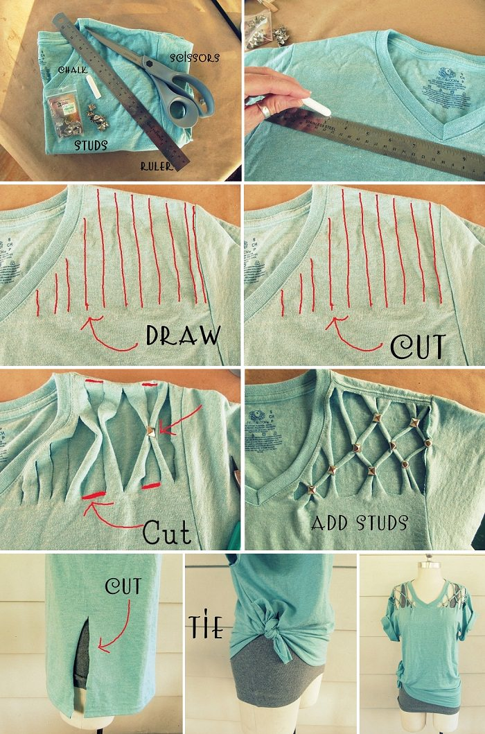
Take your tee and draw some lines along the sides of the neck horizontally. Cut them and take two at a time, combine both at the center and add a stud over it to get rid of the rough look. Try it all around and you have re-designed it to become a better top.
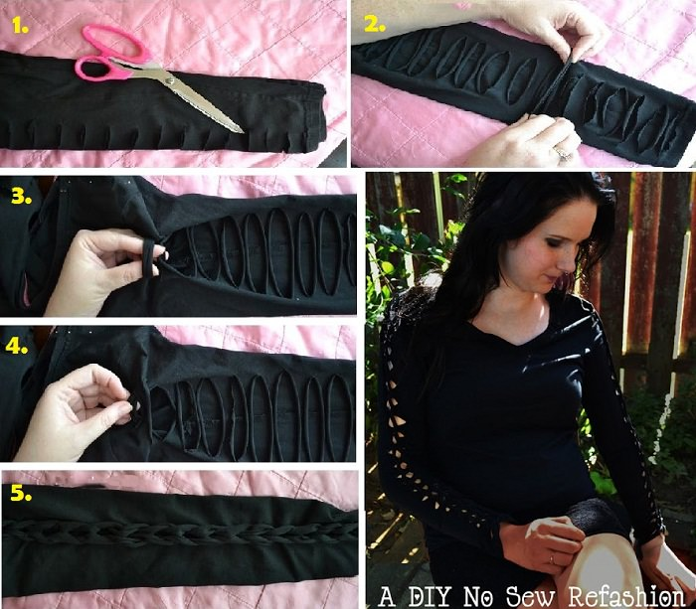
Make a normal top awesome by doing some simple cuttings on the sleeves so that it becomes little look though and get you cute and dainty looks. This way you can refashion your top to make it look different.
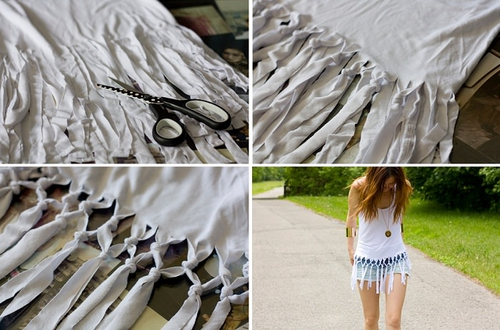
Cut the fringes from beneath and tie some knots at specific intervals in uniformity so that it looks no less than a designer top. 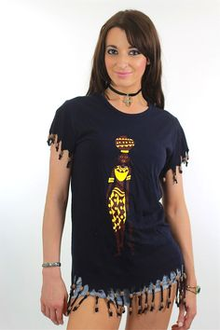
Another version is to cut strips at regular intervals and use beads and tying.
- 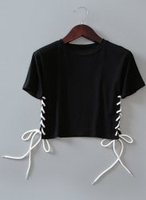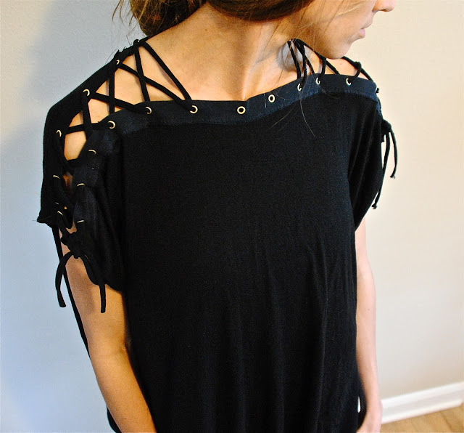

You can use oversized eyelets and fatty laces, or small grommets or eyelet strips and small laces. Your choice, and again, it can be done on any part of the shirt.

Note: This upcycled craft is recommended for 11 & younger, but again, you know your girls; their abilities and interests, so you can decide if it’s something your 12 & older girl would be interested in.

DIY “GLUE” BATIK T-SHIRTS: A COLORFUL, UPCYCLED CRAFT FOR KIDS
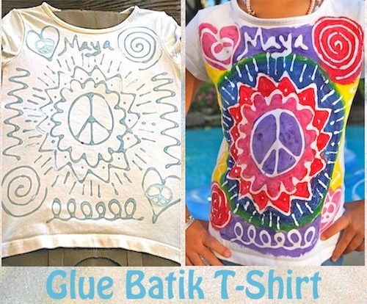
These glue batik t-shirts are inspired by traditional batik. Batik is a textile made by hand where artisans use wax to create a design, and then dye the cloth, which resists the vegetable dyes. Originally from Indonesia, batik has symbolic meanings in its colors and designs, and people use the craft to express their creativity and even spirituality. In this easy project, kids substitute hot wax for Elmer’s blue glue and convey their own creativity by choosing images that represent themselves, and colorful paint that reflect their personalities.
This post contains affiliate links. Thank you for your support!
Before making the glue batik t-shirts, first learn the history of batik and its importance today. Anthropologist believe that the wax resist technique of dyeing cloth began in the 4th BCE in Egypt, and from there spread to Asia (notably India and Japan). In Africa, people in Nigeria and Senegal also employ a similar process. Today, woman and men use batik cloth as a sarong (long fabric wrapped around them into a skirt or
dress), and mothers use batik slings to carry their babies. In 2009 UNESCO designated Indonesian batik as a “Masterpiece of Oral and Intangible Heritage of Humanity,” because the craft of batik is intertwined with the cultural identity of the Indonesian people.
While fragile, intangible cultural heritage is an important factor in maintaining cultural diversity in the face of growing globalization. An understanding of {it} helps with intercultural dialogue, and encourages mutual respect for other ways of life. The importance is… the wealth of knowledge and skills that is transmitted through it from one generation to the next.
Here is a video from the Indonesia Batik Museum Institute. From 1:20- 5:00 you will see how batik is traditionally made by drawing out the intricate designs, detailing them with pine resin or beeswax, and then dyeing the cloth with natural dyes in blue, red, brown, and yellow.

BATIK T-SHIRTS FOR KIDS
And now it’s time to make our own batik t-shirts! Gather your supplies:
- Elmer’s Blue Glue Gel (note: regular white glue doesn’t work as well- said from experience:).
- a white t-shirt (we upcycled some that had light stains!)
- acrylic paints (I supposed you could use fabric paints as well- though acrylics work just as nicely. We’ve put the shirts in the washer and dryer and have had no issues with acrylics).
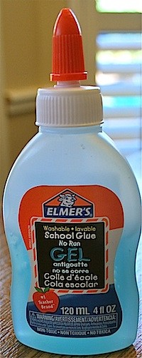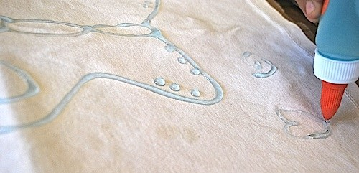
Use the glue to “draw” your image. My 7 year old was able to do this herself, while my 4 year olds dictated to me what they wanted (and helped with details). Wherever you squeeze the glue will eventually be white.
I used a brown paper bag inside the t-shirt to keep the back and front separated- this is especially important once you start painting. Let the design completely dry- we waited overnight just to be safe.
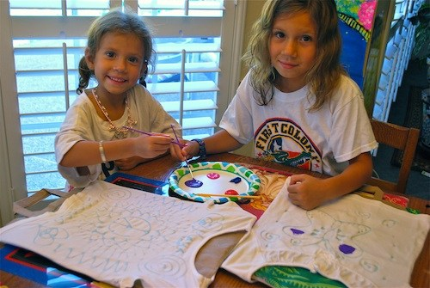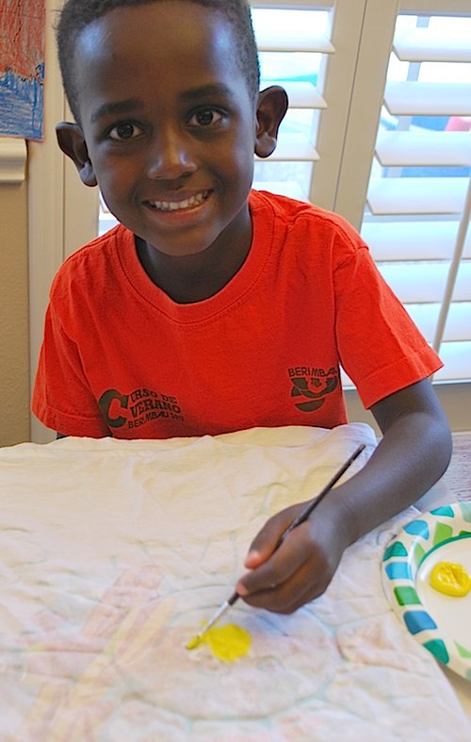

Let the kids paint the designs as they wish. My son used a LOT of paint- it was so thick that even after washing his shirt in the washer and dryer, not all of the glue was removed. It also took forever to dry- but you eventually will be able to see the batik effect (or you could always instruct the kids to use less paint if you’d like to do so). We dried ours in the sun!
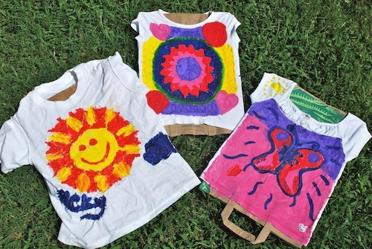
Next comes the magic! Soak the batik t-shirts in warm water overnight. The glue will begin to dissolve and reveal the white designs. We were impatient and decided to just throw them in the washer and dryer, where most of the glue came off (my girls kind-of picked off the rest of the glue). How cute are these t-shirts!? 🙂 You can see how Ricky’s still needs to be washed a couple of more times to get off the thick layer of paint over some of his glue.
